West Hull Ladies
RRC

March Newsletter

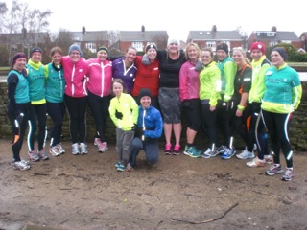

Well Done 6 Weeks to 5K Ladies
West Hull Ladies


West Hull Ladies Annual Dinner and Prize Giving
Friday 21st March, 7pm at 'The Back Room' 175A Hallgate Cottingham HU16 4BB
You are cordially invited to celebrate with us at our Annual Social Evening/AGM Event.
The AGM is a celebration of our club with prizes for the 10K Series, Member of the Year and other awards. All members including our new 0 to 5k ladies are welcome.
It’s also one of the few times to see ladies not in running kit!
Cost £15 including entry into the raffle.
Please give money/cheque to Debbie Watson/Rachael Laughton ASAP but definitely before 7th March.
Food will be a hot buffet which will include Vegetarian options.
AGM Raffle (for club funds)
Please would everyone coming to the AGM bring one raffle prize. When your number is called out you can go and choose a prize. First out of the bag has a lot to choose from but everyone goes home with a prize!
Subscriptions
Subscriptions for members (apart from the current 0 to 5k ladies) are due at the AGM. Please can you bring a cheque for £30 paid to West Hull Ladies RRC, write your name on the back with the word ‘Membership’

WEST HULL LADIES RRC
COMMITTEE MEETING

3rd March 2014
Present Jill, Sandra, Debbie, Sally, Linda, Amanda, Andrea, Ann, Verity, Zoe, Rachael, Maria.
Champagne League: Places were allocated to 10 ladies who requested a place on the basis of the number of races they could make. We are pleased to note that Sandra, Jill and Zoe have contacted City of Hull to offer their services as marshals.
1. Apologies were received from Annette and Lisa
2. The minutes of the previous meeting were agreed.
3. Jill – would send further email about presentation evening as figures needed to be in soon and Debbie would continue work on the questionnaire for the 0-5k course.
4. North Lincs Marathon meeting. Jill and Amanda attending on Saturday 8th March.
5. Nutrition talk. Chloe and Mark had agreed to do this and had suggested a date of 20th March. Amanda to arrange alternative date as 20th not convenient.
6. Kit. The company who supply us with vests had sent a long sleeved shirt. The majority of ladies liked this and Maria is to bring it to the AGM for ladies to see and take any orders. The cost of the shirt is approx. £18.50.
7. Discussion took place on the agenda for the AGM. Awards had been sorted and Rachael, Debbie and Sandra to visit venue 13th March to confirm numbers and food. Verity had managed to obtain the use of a projector.
8. Amanda asked if the club wished to support the Sports Relief Mile, which was to be held at the University on 23rd March. Amanda to obtain further details and circulate. Rachael asked if as a club we could again do the ‘bleep’ test. Amanda to arrange.
9. Linda informed us that she had sent a text to the Burnsy show on Radio Humberside after an article about sport for Ladies. Her text was read out and gained good publicity for the Club. Verity stated that the projector she had use of was possibly available to us if we were willing to contribute to school’s charity by way of a one off donation. Everyone present agreed to this and suggested a sum of £30. Verity to progress and report back

6 Weeks to 5K - parkruns

15th February 2014
To steal a line from Kate Bush, "WOW! Unbelievable!" A thoroughly horrible, wet and very windy morning and yet the Six Weeks to 5K ladies were out and doing a fantastic job.

Sandra: It is difficult to find words that actually express how well you all did today. It was a pretty horrible morning with high winds which were also bitterly cold together with rain. But did that deter you - no - not once we had got you out of the warmth of the cafe/toilet block!

Throughout you all had beaming smiles and you were so enthusiastic and such a joy to be with. You all did so well and should be very proud of yourselves and each other. What was lovely to see was how supportive you were of each other. What a fabulous group of women you are and it has been a real pleasure to meet you and see you develop from - dare I say it - couch potatoes to runners!!
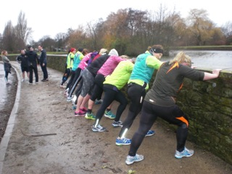
So a big thank you to you all and to all the buddies and trainers who have helped you start your running journey. Can't wait for the Beverley 10k - you will all be fantastic.

I have to say as well that I was so impressed with you all doing your stretches at the end - Amanda has taught you well!

You all thoroughly deserved your coffee and cake.

Carol: An amazing turn out for the parkrun on a very wet and windy day.
Ladies, you are all amazing and what a fantastic achievement in a short space of time. One thing I noticed at the end of the parkrun was that you all had big smiles which can only mean one thing: you are finding this running lark enjoyable and addictive!!!

I just want to say I've really enjoyed helping with buddying on these sessions. Seeing you all progress in the last 6 weeks makes me feel very proud. I hope you will all continue to come along to the club sessions and before you know it you will be running 10k comfortably thanks to the way Amanda has structured the weekly sessions and you will have plenty of support from us.

Linda: The East Park parkrun, which I’ve never done before (I’ve only done three Peter Pan ones), was fab. Ok the weather was awful but I suppose that’s to be expected at this time of the year and by now I’m sure we are all used to getting wet!

The 0-5K ladies very first event and boy did they look like they were enjoying it despite the weather. They all did fab, I ran all the way with Tracey and although I know she was finding it hard after 2 miles I knew she could make it without stopping, and she did. We were overtaken by Hayley just near the end (cheeky girl), but the finish was fantastic with everyone getting together for the photo shoot that Sandra was organising. Thanks Sandra for supporting and taking pictures and thanks to Debbie too for encouraging everyone along the way.

I hadn’t realised just how popular East Park is, there were lots and lots of runners unlike Peter Pan where there are only a few. I much preferred doing the route twice instead of three times too.

Well done to all the 0-5k ladies and now you have had a ‘taster’ I know you will enjoy all the other training until you reach yet another goal the 10K. WHL are behind you all the way.

Clare: Well I have managed to finally calm down, after having the most amazing morning in the extreme weather conditions and for once I am not exaggerating. At one point I thought I would be joining the ducks for a swim!! Anyway, big massive thanks to Andrea for being my running buddy and keeping me going today. There was never a question in my mind that I wouldn't do it but Andrea kept me going with the pace, encouragement and general good conversation.

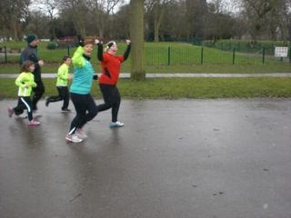
Along the way we managed to encourage a random man who was seeming to struggle. He somehow managed to pass us and at the end I tried so hard to sprint past him but he caught on so we were literally sprinting to beat each other. He won, however only by a metre, when we start speed training he will be eating my dust!!!

All the ladies did great today and the support from all the buddies who came today was amazing. Sandra miraculously appeared everywhere like the paparazzi and even shouted words of encouragement across the lake ☺
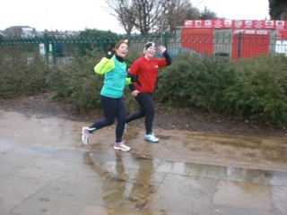
All in all a fab day which has been the perfect end to 6 weeks. Of course this is just the start but without the help, advice, and guidance from everyone I'm not sure if it would have been possible.

So massive thanks to everyone, I'm still smiling like a Cheshire Cat.

P.S. the coffee and flap jack afterwards were totes amaze ☺

Sarah W: Ran 5k without stopping - TICK.
Well what a fantastic end to a fantastic 6 weeks, the weather was horrendous, I found it harder to run, luckily I had no pain and with the encouragement of you lovely buddies was able to complete the course without stopping. Kate and Carol you was absolute stars today and want to say thank you for making me have belief in myself that I could do it.

The six weeks have been amazing, the buddies week in and week out was friendly, encouraging and made you feel like a club member already! I have never met such a friendly club.
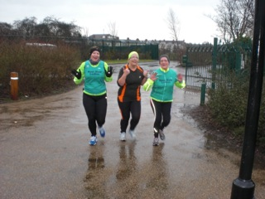
Running constantly at the back is hard mentally, one particular hard run made me think what's the point of carrying on if I'm not able to keep up, but the buddies all of you made me feel like it doesn't matter how slow you run it's about finishing and you guys have given me soo much encouragement, one on one coaching that the other members didn't get by running as a pair so I'm a winner really :) so I would like to say a special thanks to all the buddies that kept me company ☺

Today's run and how friendly the club is has made me believe that I will get to running that Beverley 10k with no problems!!! You rock and us beginners rock!!! This time next year I would like to think I'll be just as encouraging and awesome to the newbies as you lot have been to us.

Rachel: So my results are in and I'm so proud of myself! 5k in 36.44. I never ever thought that would be possible and I couldn't have done it without the support of you ladies! I had a lot of fun today! I think I set off a bit too fast on the first lap so at the beginning of the second lap I stopped to walk for a minute. Carol came and caught up with me and with her support I carried on and ran the rest of the way! Without that support I don't think I'd have found the strength to carry on so thank you Carol! I did run for 20 minutes before I stopped. Towards the end of the second lap I had a real mental battle with myself and I really wanted to stop and walk but having Carol there with me spurred me on! The wind and rain near the bottom of the course didn't help either!

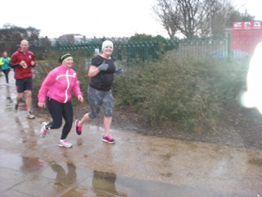
I really enjoyed today! It was harder than I expected but I'm proud that in 6 weeks I've gone from barely being able to run to running 5k! Everyone did so well today! Well done ladies, let's keep it up!

Hayley: First of all I just want to say how much I enjoyed parkrun on Saturday even though the weather was dreadful! I felt really comfortable the whole way round and felt like I could've done another lap at the end - all thanks to your wonderful training over the last 6 weeks!

Thank you all for the great training, support and for having such a friendly club.

Tracey: In October 2011 I went down to Nottingham to see a specialist respiratory doctor. At that time I was a keen scuba diver and due to fly out to Spain to do some deep wreck diving. Trouble is, as an asthmatic you need medical clearance and a fitness test to do so.

At well over 13 stone I knew that I’d struggle to pass and at only 2 minutes into the testing I tore my calf muscle badly – it was like being shot in the leg! Convinced I had a bad cramp I continued and somehow managed to scrape through the test. With a calf muscle full of blood and in a lot of pain, I was on crutches for a week afterwards – no fun at all!

I vowed then that I was not only going to lose 3 stone but I was going to get fitter and healthier– after all, who goes to fitness test and ends up injured?? I had tried every diet known to man, and whilst they worked in the short term the weight seemed to creep back on when I was no longer dieting. The very word ‘diet’ made me feel hungry! Fed up of being a yo-yo’er and eating different meals from everyone else in the house, I chose to change my lifestyle and watch my calorie intake too. It’s surprising how much you consume when you start to write it down – some days were just plain scary! I’m not a fan of cutting out major food groups – I wanted to eat what the rest of my family were, I just needed to cut down the portion size and be sensible during the rest of the day. Exercise was also needed and I always seemed to have every excuse under the sun not to do any!!

Swimming was the natural choice for me – no one could see may pale wobbly bits as I was under the water and no embarrassing sweaty clothing!! The weight started to shift and I started to get a bit of a buzz from it all. I also live in a house full of cycling nuts, and with my husband having lost 3 stone by cycling I thought I’d give that a try too. I got my first bike the following April through the cycle to work scheme and started to ride the 5 mile round trip to work 3 times a week. I was absolutely hopeless, it took forever to get to work and I was a stinking, breathless bundle of no joy!! I joined a local ladies cycling club and with their encouragement, enthusiasm and love of nice cafes with lovely cakes, I really started to enjoy it. Cycling had taken over my free time and there was no time to swim anymore – besides which, the summer weather was glorious and sitting outside country pubs after a bike ride was far more appealing! Riding 50-120 miles a week was by now comfortable. The weight continued to shift too despite all the cider and fruit loaf.

I met Zoe and Jill Jameson at the cycling club Christmas night out and they mentioned the 0 – 5k course. I had been trying to do the parkrun with one of the other nurses at work but could only manage to run maybe for a minute or two and then walk a minute. Thinking I was relatively fit, it was frustrating to be so rubbish at it! Zoe and Jill were so encouraging and I knew the power of being supported worked from joining the ladies cycling club and so readily signed up.

I had been advised by a friend that my 12 year old tennis shoes were perhaps not the best thing to run in and so bought a decent pair – what a difference! The short runs at first were really hard but with all the buddies turning out religiously to help really made all the difference. Their enthusiasm was contagious amongst us and it was so amazing that so much chatting could still take place despite being frequently out of puff and battling with a stitch!! Soon the runs were becoming longer and longer .I’d wait for Amanda’s email at the end of the week with the following weeks training on – open it up with trepidation and sigh – how exactly was I going to run for so many minutes without a break? It just seemed impossible at the time but we all did it thanks to lots of support and positivity.

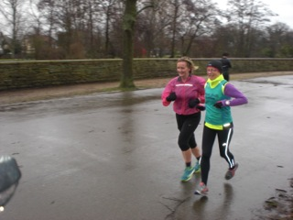
The parkrun loomed – the last time I had done it I had managed to run for 12 minutes only and walked a lot of the rest of the way round. The weather was foul – wind, gusts of 45mph, rain, puddles and fallen bits of trees to jump over. Sarah and I sat in her nice warm car wondering what the heck we were doing there – had we completely lost our marbles? We met up with everyone else, the atmosphere was great and it was so wonderful to see so many buddies that had turned out on such a horrid day to help, I can’t begin to tell you how much of a difference it makes.

I thought I started quite slowly but I think I got carried away with it all and actually was probably a bit too quick in the beginning to be honest. Linda was lovely and ran by my side, words of encouragement kept me going. I briefly looked at my phone for the time – 22 minutes in and I hadn’t stopped, how did that happen?? By the 2 and a half mile mark I started to struggle and told Linda. Hoping she would suggest a walk she suggested that we just slow it down a bit! Not the right answer said my head but I’m very glad we didn’t stop. I found a slower rhythm and carried on. Finishing felt amazing and not only had I done the whole thing without stopping, I had taken 4 and a half minutes off my previous parkrun time.

Thank you West Hull Ladies!! You gave me the encouragement and belief in myself that I could do this. For all the nights you’ve turned out to shepherd us along, despite the hideous weather conditions at times, I’m very grateful. Somehow you’ve also managed to brainwash me into believing that I can do the Beverley 10k – Oh Lordy - how did that happen?? What I do know though is, that with your help I will be able to do it!!

Oh yes, and by the way – during the 6 week course I’ve lost 5lbs - another reason to take up running!! I’m 4lbs off having lost 3 stone so far with another stone to go – hmm maybe triathlon next year? Will this endorphin addiction ever stop??

Shirley: I just wanted to thank you so much for helping us manage 5k.

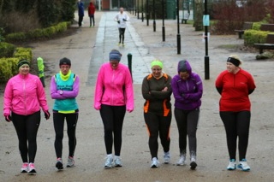
If the story of Saturday's park run could be told in photos the beginning would look like this - Cold and a bit daunted with ten minutes to go; but there were buddies making sure we didn't leg it

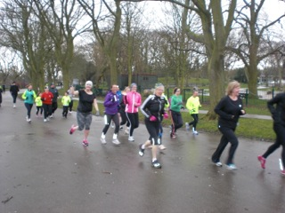
Underway we looked a bit like this as it was probably the worst weather we've run in yet.

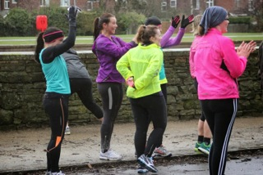
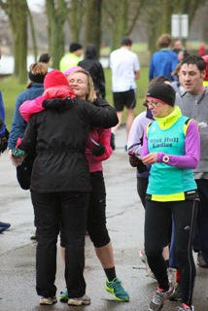
Those who finished cheered for those yet to finish and when we'd finished we felt like this (lots of soggy congratulatory hugs)
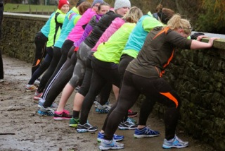
And then we settled down to our stretches before heading off for a celebratory cuppa in the cafe.

Thanks so much to those who gave up their time to buddy for the 6 weeks beforehand to make it all possible, to those who turned up on the day to buddy/take photos and cheer us on and celebrate our achievement with us.

Let's hope this is only the beginning of our running.

22nd February 2014
Sandra: Weather-wise was 100% improvement on last week!

It was the first time out for Beryl and Christine who were unable to make last week. They both stormed it -Beryl doing an incredible time of 33.02 and looking very strong. Christine also did brilliantly running in with Susan.

What can I say about the other beginner ladies, Clare, Sarah, Rachel, Tracey all running PB's and Shirley only being 29 seconds outside of hers. That is brilliant ladies and you made it look so easy. By the smiles on your faces you are all enjoying yourself.
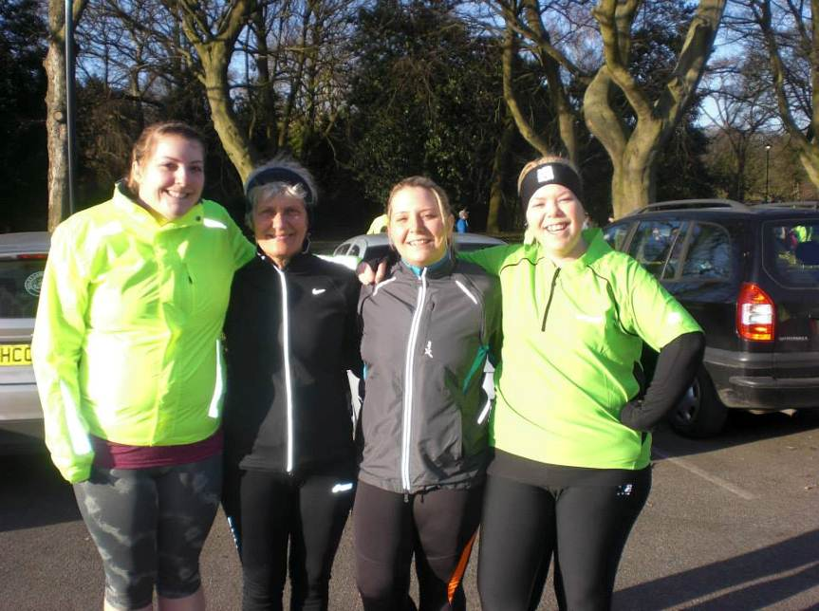
What a fantastic start to the morning - well done everyone - you should all be very proud of yourselves.

Beryl: Wow, what can I say I really surprised myself, special thanks to Sandra who encouraged & supported me all the way and also Carol who in spite of a calf muscle problem accompanied us. Without all you lovely ladies new & old this would not have been possible you’re a great bunch. Oh I forgot to mention my lovely daughter Lynne who mentioned to me last weekend when running that I was too slow to run with her therefore I feel she inspired me in a way to do well.

Can I just say it wasn’t Intentional to achieve a fast time I was just focussed on completing the run without stopping. Special thanks for all the encouragement & support I received from each & everyone. I joined the beginners for advice & technique & I have received far more than I imagined in those 6 weeks.

Stratford Valentine’s Marathon

Ann

This event was a test of five things

- Would my new trail shoes hold up over a long distance?
- Would my left calf be ok over a long distance?
- Would my right knee be ok over a long distance?
- Would I be able to use a race as a training run and not go too fast?
- Would I be able to run a trail marathon having only trained on roads?

This was a very low key event run by a chap called Chris, who I was very suspicious of. Over Christmas I’d gone part way through an entry to this event, because I didn’t believe that an event of this scale would actually cost £50. I stopped short of paying an extortionate fee, but the next day he rang me, and asked if that was why I’d not proceeded with my entry. When I said ‘yes’ he said he’d only put the price up to put people off entering because it was getting a bit full, but that he’d been to Hull and liked it, so if I still wanted to enter he’d make an exception and let me enter for the £24 it was originally! I was very suspicious about this … but it turned out he was legit - a bit odd, but legit nevertheless.

I stayed with my dad the night before, and he kindly drove the 40 min journey to the start point, which was an old railway carriage near Stratford on a cycle path called the Greenway. I was asked what time did I want to start … talk about informal!! I’d missed the 8 o’clock start, didn’t want to rush for the 8.15, so plumped for 8.30, since I knew it was the faster ones that would be setting off at 9. So there I was, with about 8 other people and two dogs whilst Chris recited a bit of Henry V “Once more unto the breach, dear friends …” and we were off.

The route was supposed to consist of four different loops, returning to the railway carriage each time, but the first planned route was water logged, so this was replaced with a 4 mile out and back of the cycle track, which was easy enough. It was odd meeting the 8 and 9 o clockers along the way. Then up the steps into the railway carriage for a water stop (there were in fact two carriages, one was normally a cycle hire office, but was today’s race HQ and the other was a cafe, and today’s first feed station - well, a table with jugs of water and juice, and a plate of bourbons.

The next loop took us towards town, then over a bridge over the Avon and off onto a cross country track - UP HILL! He said it was flat … flat it was not … uphill and THE MOST fierce headwind EVER … even walking was difficult. No worries, this was training run, not a race, and with ultra running walking is part of the package, so I decided it wouldn’t hurt to walk here and there, so I did.

This loop was called ‘Kim’s loop’, because half way around was feed station two - at Kim’s house! This was a table set up on the drive with crisps, biscuits, energy bars, juice and water - novel, but perfectly adequate.

Loop number three was a longer out and back on the cycle track, with BIG puddles, so big it was impossible to avoid them, so I just submitted to continuous wet feet, which was fine, in fact. The feed station for this loop was the boot of someone’s car!

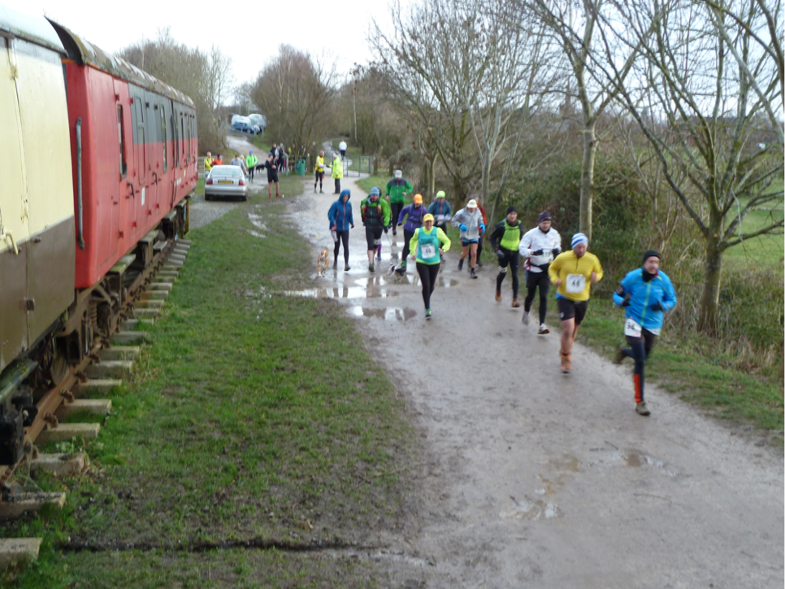
When I got back to the railway carriage where poor dad was sat reading his book I started to feel a little guilty because he was really cold, bless him. One lap left - back up THAT HILL, with THAT WIND, and on my own this time, as the runners were very spaced out by this point in the race. Head down, keep moving, and get it done. And I did.

I’d wanted to do this race without any niggles from various places, and I did - the only problem I’d had was the biggest blood blister I’ve ever seen, but I hadn’t even known I had this until I took my shoes off - the rest of me was fine, so job done. Now I just needed to de-frost my dad!

This was a very different sort of event, but actually very well organised - the feed stations were at all the right places, and were stocked with just what I needed. People were very friendly. Even the goody bag was better than I’ve had at much more expensive events, with a decent technical T shirt as well.

Happy days!

Can I take this opportunity to thank everyone who has been so generous in support of my London to Brighton run, and for those who have been meaning to visit it … here’s my fundraising page -

www.justgiving.com/daisyholmes



Snake Lane 10

Anna
When we sat in Amanda s living room having our Christmas mulled wine, talk got round to goals for 2014. I tried to keep quiet but everyone else remembered that I had put my name down for snake lane. So I had to declare then, that that would be my goal. Not to run it, but just to be brave enough to turn up!!

I figured even a walk of ten miles was manageable, but then over Christmas I devised a rough plan to get up to running that distance in time. Well life had other ideas, and I was out of running action for the first two weeks - behind already. But when I came back to the club Amanda did a bit of running matchmaking and paired me up with Trish who had also been away from the club and was also trying to prepare for snake lane.

We started a Sunday morning meet up, and asked Ruth to join us as she also had a place. Every Sunday morning we met up in the avenues and gradually increased our distance until the week before Ruth took us all up castle hill and back. This gave me masses of confidence, as I had never run more than 8 miles before.

On the day I felt really excited- I was desperate to start it as I had been thinking about it for so long. It turned into a race of two halves for me. The first six miles were great-I felt really comfortable, and Ruth and I were managing ten minute miles, and could see Jill and Jermaine just up in front of us. The scenery was pretty and we were happy chatting as we ran.
At mile six we came out of Bishop Wilton and this is where I wish it had been a ten km not ten mile run. From there on I really struggled. The wind was awful - we were running straight into it, which was such hard work. Everyone we had gently overtaken was now overtaking us, and all the good time we had made was slipping. When we hit the main road my heart sank - all I could see was a line of hunched up runners ploughing into the wind, and a long straight boring road to finish off. At the nine mile marker I just felt like I couldn’t do it rather than being pleased we were nearly there. Ruth and I tucked in behind a group of runners going at a manageable pace, and we decided to try to keep in with them. Then into Pocklington, Sandra and Linda ran with us- it was so lovely to see them, and they must have given me that little push to get over the finish, as I really was worrying if I was going to make it!

As at the beginning, it was wonderful to see everyone and I was so proud of everyone.

Thank you to the club for not laughing at me when I said I had entered it. Thank you to my little training team - Trish managed to really improve my speed, and Ruth managed to improve my distance - I wouldn't have done either if I had trained on my own. And thank you to the girls on the day. We had a great day out and Sharron was a super supporter, and calmed me right down. Thanks Ruth, and sorry again for being grumpy at the end, and thanks club for amazing support!!

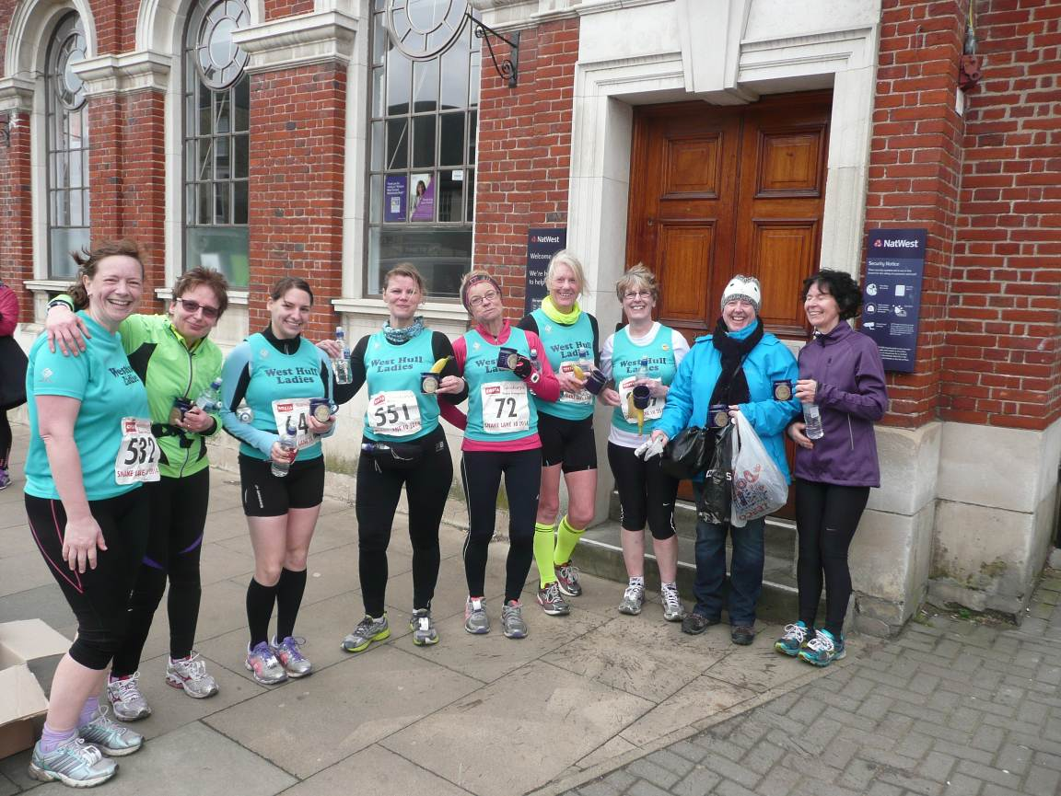
Jill
I came up to this event on the back of having fallen down and injuring my knee doing the 0 to 5k sessions. I thought I had got away with this but have somehow ended up with a swollen knee, which is not particularly painful, but limits the movement in my leg. Having visited Jamie Barrington, I got ‘permission’ to run the races that I have entered as long as I do them as training runs, and that I should cycle in the meantime and only run short distances. This has been a bit of a blow as I am supposed to be training for London. Anyway this background meant that I went into this race feeling quite negative, and very close to thinking that I wouldn’t do it. Fortunately, Jermaine had been in touch and having been out for a number of months with a broken ankle, was keen to run the race at a steady pace, as this was only the second time she had run since recovering from this break. So as walking wounded…we decided to run together.

Jermaines enthusiasm started to rub off on me in the car going to the event, and I felt much better by the time me, Zoe and Jermaine arrived at the event HQ. Meeting up with Sandra, Trish, Linda, Anna and Ruth, was also really nice, and to have Sharron in support was fab. All of this made me feel much better about the whole thing, and proves to me how the positive support of others is so important in our running. Anyway we started off and the first five miles were very pleasant…nice scenery, chatting with Jermaine, back wind, friendly marshals and quite sheltered lanes. We did a high 5 with each other at half way (had to do it twice as missed first time…fail), and both of us were relatively happy about our respective injury problems, that seemed to be holding up okay.

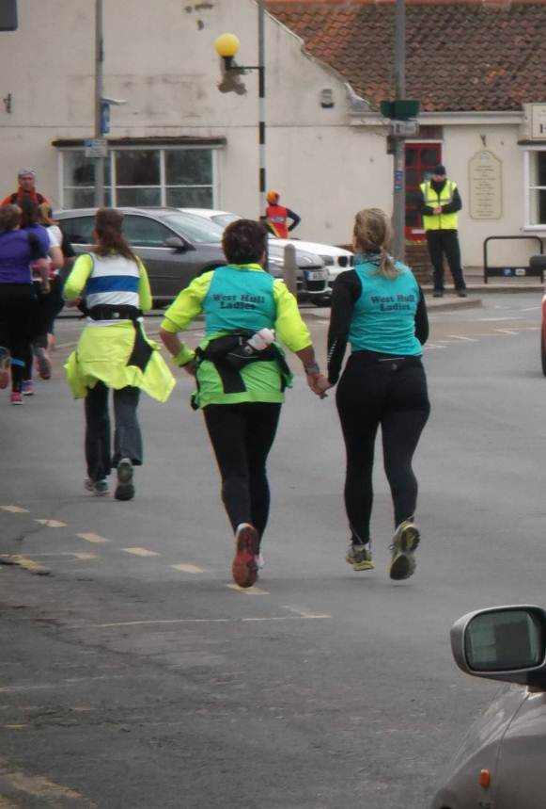
After Bishop Wilton however, we reached a flat bendy (snake?) lane and turned into the wind which was really strong. This was really hard work as it alternated between head and side winds, and there was very little shelter…and certainly stopped our happy chatter! I also decided to have a gel at six miles, and having tucked the sticky empty pack down my running tights to avoid littering the lovely countryside, had it migrate down my trouser leg. I then had to extract it by putting my hand down the back of my tights…I think the chap behind me thought I was having a good scratch (How embarrassing!). Fairly soon we found ourselves heading back into Pocklington and got great support from Zoe, Sandra, Trish, and Linda, who had finished, with Sharron in photography mode! I think that we finished really strongly, given our injury issues and both myself and Jermaine, were over the moon that we had done it! Did another photo shoot when Anna and Ruth finished very soon after us! Everyone seemed really made up with their performances which was great, and to have support from Sharron was really nice too. Thanks West Hull Ladies once again for making me feel good about my running, when I was really quite down about it!

Zoe
I entered Snake Lane thinking that it would be a good stepping stone and confidence booster in my marathon preparation. As such, I woke up on the Sunday morning having slept really well and not feeling particularly nervous. I had caught a cold from work and didn’t really expect a good time.
I had promised myself several things:
- Not to set off too fast
- Not to look at my watch
- To remember to eat at the water station
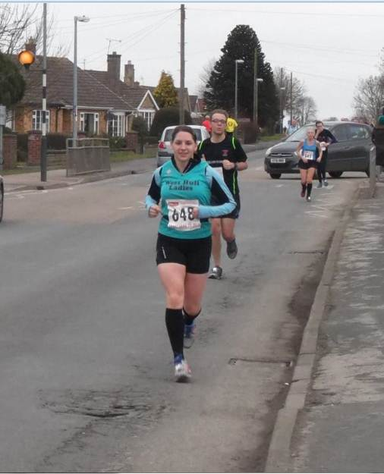
I set off with Sandra as she was aiming for 9 min/mile. However, the first mile was an 8.17 min/mile (OOPS!) but it did feel comfortable as we were going downhill so I kept it going. The first 3 miles went past quickly in Sandra’s company with some chatting and a nice tail wind. I had found a good rhythm and felt like I had warmed up so decided to increase the pace. I reached the water station at 5 miles and ate part of my bar. I had to walk whilst I had a drink (I haven’t yet worked out how to drink water from a plastic cup on the move without most of it going up my nose, lol). I felt good at this, the halfway point and as a reward for running well, allowed myself a look at my watch: THE FIRST AND ONLY LOOK AT MY WATCH ☺.

In the second half of the race it became a bit blustery (correction: VERY blustery). The ‘snaking’ lane allowed me to shelter from the head wind behind tall men (There are advantages to been small!) then up the pace to reach the next tall man when I had a side or tail wind before sheltering again on the next stretch with a head wind.

The final 3 miles were the most difficult. The wind was trying to push me off my feet and going up the hills I felt like I was getting slower and slower. I was happy to see the Pocklington sign and start running down the hill towards the finish line. Part way down I saw Sharron with her camera and she shouted me on towards the finish. This spurred me on to catch and pass a couple more people. I crossed the finish line and looked at my watch. I completed the 10 miles in 1hr 25min 20secs which is 4 mins off my PB but I was happy with it.

This was the first time in a long time that I had enjoyed a race despite the less than ideal conditions. It was a nice course and a great atmosphere with an amazing group of West Hull Ladies both running and supporting.

Ruth
☺
My running buddy Sharron and I had entered The Snake Lane 10, (or Snack Lane 10 as I inadvertently typed once or twice) but Sharron became indisposed and I was faced with the thought of running the race alone, without any chatting. Fortunately for me Anna was also doing the race and we agreed to run together. We trained together a bit, and we seemed to have a similar pace.......so, bring on the big day. It arrived, I drove Trish and Sharron (in her capacity as supporter, photographer, carrier of bags and coats) to Pocklington, met Anna and all the other ladies, and we were off.

Anna and I were literally at the back, but, chatting happily, we started to overtake people. Mile 1 went by really quickly, mile 2 also sped by, mile 3 involved a bit of a slowdown (in both speed and chatting) because there seemed to be a slight up-hill pull, mile 4 was good for 3 reasons; a) it was down-hill, b) Bishop Wilton is so pretty, c) there was the prospect of a water station. The water station was at mile 5, and I thought we were averaging just over 10 minute miles. Not fast for most WH ladies, but super speedy for me. Then it all started to unravel............the race route then became more exposed, and we were being buffeted by strong winds either to our face or side, but at least it wasn't raining. We felt the need to walk a bit, so most of the people we had passed started to pass us, and the last 5 miles were just a hard slog. The last mile was really difficult for me, Pocklington didn't seem to be getting any nearer, and then, like angels, Linda and Sandra arrived to run with us and encourage us in. All the West Hull Ladies were waiting near the finish line to cheers us in, and super-snapper Sharron was doing her stuff.

I wanted to get round in under 2 hours, and did it in 1 hour, 52 minutes and some seconds, (can't remember how many) so, after I stopped feeling sick, I started to feel really pleased.

Revived by a banana and some water Trish, Sharron and I set off back for Hull. Sharon then took on her next role, provider of food, and on the way back we were offered a variety of food of which I ate salt and vinegar crisps and Quorn sandwiches. It was wonderful to have someone looking after us. Thanks to Sharron. And at that point the race really did become the Snack Lane 10.

Can I just say a) how proud I was of Anna, the furthest she had raced before was 10k, and the furthest she had run (only the previous week) was 9 miles and b) how grateful I am to her, she was wonderful, getting me round when I was really flagging at the end.

Anyway, would I run it again? Good question. I ran it before, back in 2009, and for 5 years remembered what it was like and felt absolutely no desire to run it again. Maybe the answer is, I might run it again, but not necessarily very soon, unless Sharron catches me at a weak moment again ☺

Golden Fleece

Linda
I think it was Ann that said on Face Book if I was doing the Golden Fleece and would I do the 27.5 miles and unbeknown to me my fingers typed out the words ‘oh, go on then’ then they pressed the return key and there it was for all to see (how did that happen)! Too late I’d made the commitment.
So the morning arrived, very foggy and quite cold but thankfully no rain and no wind. I started to walk to Cave Castle but had only got to Beverley Road and along came Verity with Simon who pulled over to give me a lift. Thank you Verity and Simon, that made my morning.
When we arrived at the Family Centre everyone was there, Sandra, (and her brother), Ann, Becca, Zoe, Lynne, so we joined them in readiness for the start. There were lots of other runners plus walkers, think the event was supported well maybe more than 300 people which is great.
We set off nice and steady, having Ann with us to remind us we had a long way to go, thanks Ann this really helped could have so easily started off too fast. We stayed together and before long we had come to the junction where the shorter route went one way and we went the other. Think I was a little envious that they would be finished and showered long before me! But the best bit was meeting up with Amanda at this point, she took some photos and gave us all a hug, she was so cold having come on her bike to be WHL support. Thank you Amanda.
So off we went, out into the unknown (well to me anyway as I hadn’t been part of the recce that had done this bit of the route). I loved the uphills, just hearing Ann shout ‘HILL’ meant we could have a walk, although she’s very good at marching! Before long we were at halfway, this event has lots of checkpoints and they all had drinks, cake, sweets, flapjack (the flapjack kept me going, think I had a slice at every checkpoint)!
By now the fog had lifted and the sun had come out to play, the views are beautiful we are so lucky living in this part of country where we can enjoy so many off road runs/walks in the countryside. Unfortunately our poor Verity took a tumble but thankfully she wasn’t hurt just a little muddy.
The four of us seemed to be just about the only people around, what happened to everyone else, although there were two ladies running sometimes behind us and sometimes in front as they kept going in the wrong direction! The company of Verity, Becca and Ann was great, plenty of chatting and laughing about all sorts of topics. Thanks girls for the company.
At last the end was in sight, we whooped when we past the marathon distance and now just the last effort to get us back to the Family Centre and stew and tea which we knew was waiting for us, but the last bit was quite tough, two big hills then finally down into South Cave. Just half a mile left and we were home and dry. It took us 6 hours 24 minutes so we well deserved the stew, we’d done the 27.5 miles so now we could say we’d done an ultra!
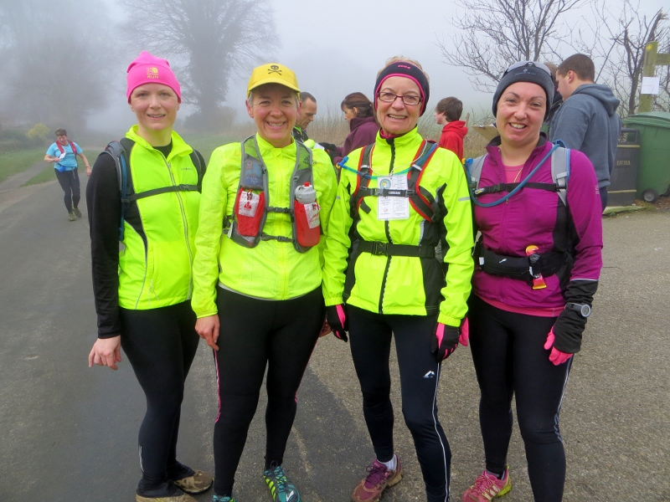
It was a fantastic day and yes my legs are ‘singing’ and my two big toes are throbbing but it was so worth it. Thank you again Verity, Ann and Becca hope we can do the same next year.
Ann
The key questions for this event were
* Am I ready for mud and hills and looong miles on (for me) challenging terrain?
* Can I eat and run?
* Will I be able to keep up with Verity, and if not, will Linda know where to go?

I was a little under-prepared for this, and ended up downloading route information way too late the night before, but at least I had the full route saved to my iPhone, and a written description on separate, throw away-able pieces of paper, with mileage. I figured that’d have to do - put my faith in the others to get me around.

I was way too early, and sat chatting away to a fellow called Tom, who told me about his entry into the second ever London marathon - in those days it was postal entry, but even then it was so popular there was a first come, first served system, whereby only the first 20 from each sorting office would get a place. This meant that Tom queued through the night to bag his entry, and loved every minute of it … so excited!!

The others appeared, one toilet visit - this is progress, I usually aim for 4 toilet visits, but with only two Porta loos outside, I decided to just do one really good one and be happy with that. As it got nearer to 8.30 we all gathered outside, where a guy stood on a wall and told us not to get lost or break a leg, and we were off.

I shouldn’t have worried about trying to keep up with Verity - it turns out our long runs are pretty much at the same pace … it was Linda I had to worry about 10 minute milling at one point! Now a road marathon, yes, but off-road? … there was no way I’d survive the distance at this pace. I raised my concern, and tried to hold back a bit. Luckily for me the pace did drop back a bit after a mile or so, and imagine the thrill when we got to the first hill and started to walk! This was a strategy I was happy with.

It was great to see the others (the 16 milers) and Amanda at the split point - she looked frozen, but it was very much appreciated, as was the cherry shortbread!

The miles came and went, the fog went, and quite a few cakes and biscuits went as well … in fact I did start to think I should show a bit of restraint in that department, but they were so lovely. Luckily the eat and run question was absolutely fine.

This was certainly a challenging run for me - particularly in the later miles, when my knee was hurting quite a lot, and I was falling back quite a bit … I had to battle with some negative thoughts about London to Brighton being more than twice this and I’m already struggling, everyone’s doing better than me etc, etc. But I was able to recognise that these were not helpful thoughts, so acknowledged them, but didn’t allow myself to dwell on them. Mental toughness …

We kept going, and ticking off the miles - seeing Skidby Mill in the distance was encouraging. We plodded on, and on, and on … then there was this almighty big hill that was actually a joy to climb, because it was a great opportunity to stretch out my calves, and then we could see South Cave! A mostly downhill last couple of miles was lovely - the sun was out, and spirits were high.

And that was it - we’d done it! Thanks to my running buddies Verity, Becca and Linda - you were great, and so strong!

I was very happy to finish, and even more so when I tasted the stew - this was genius - a vegetarian stew with a separate bowl of chunks of corned beef that the carnivores could add for protein - wonderful!! I so enjoyed that - a rich reward indeed!!

Becca

I was very excited about this run. Although I have done the Rudolph’s Romp a couple times I have never run marathon distance before so was pleased to have a chance to do more than 26.2 while still running off road – which I love!

It was forecast to be dry and although it started out foggy, that was preferable to the strong wind we faced on some of the training runs. I knew it was going to be a good day when I found out my number was 118! Thanks to Jill for letting me take her number.

We ended up in a group of 4; Verity, Ann, Linda and me. It was a good size group and we all seemed to be pretty well matched pace wise. One of the things I love about this type of run is the ability to have a chat and encourage one another (and of course the cake at the check points!) It was lovely to see Amanda at the check point where the longer and shorter route split off from one another. She was freezing so it was nice of her to hang around to cheer us on.

At some point the fog lifted and the sun came out. It was a perfect spring day. The miles came and went – I’m not sure what happened when as I try not to count the miles off on a run this length. My approach is that we are either almost half way, and once past half way we are almost finished! There were a couple of ladies from Derbyshire who kept us entertained on the way round. They kept getting lost and popping up all over the place in front and behind us.

I think everyone was very tired by the time we finished but we all pulled together and ran the last leg through South Cave. There was veg stew with squares of corned beef being dished out at the end. It was the nicest thing I have ever tasted! It’s amazing what running a long way does for your appreciation of food. The ladies from Derbyshire arrived at the end after us; they had covered over 30 miles as a result of their route mishaps – but they seemed to have enjoyed it.

Roll on the next one. I understand there is a 20 miler in May if anyone is interested in joining me…?

Racing and Running Events
Fancy something different? For worldwide marathons click here

Date/Time | Event | Fee | Entry forms | Online entry
March 2014
9th/10:00 | East Hull 20 | £18 UKA/£20 | Entry form | Online entry (+£1.80)
16th/TBC | Gainsborough 10K | £12 UKA/£14 | Online entries only | Online entry
April 2014
6th/11:00 | Hornsea Third | £11 UKA/£13 | Entry form | Online entry
6th/09:00 | Sheffield Half Marathon | £24 UKA/£26 | Entry form | Online entry (+£1)
6th/09:00 | Greater Manchester Marathon | £47.95 UKA/£49.95 | Online entries only | Online entry
6th/09:30 | Blackpool Marathon | £30 UKA/£32 | Online entries only | Online entry
6th/09:30 | Blackpool Half Marathon | £20 UKA/£22 | Online entries only | Online entry
13th/10:00 | London Marathon | Race Full | Race Full | Race Full
18th/10:30 | Bridlington Easter 5 Mile Dash | £13 UKA/£15 | Entry form | Online entry
May 2014
4th/09:00 | North Lincolnshire Half Marathon | £24.50 UKA/£26.50 | Online entries only | Online entry
11th/11:15 | Beverley 10K | Race Full | Race Full | Race Full


Keep checking the website for new races and updates: www.westhullladies.org.uk/races.htm Zoe, Racing Officer

NOTE: Club Vests must be worn at any races you enter
under the West Hull Ladies running club name.
Clubwear
PRICES:
Vest | £16.00 | All items are ordered on request and must be paid for at time of ordering. To place an order please print the kit order form and hand completed forms to Maria.
T- shirt | £16.50
Long Sleeve Top | £18.50
Beanie Hat | £6.50
West Hull Ladies Road Running Club
Kit Order Form

FORENAME ___________________________________

SURNAME ___________________________________

ORDER - tick what you require, with size Price

- VEST SIZE _____________ £16.00
- T SHIRT SIZE _____________ £16.50
- LONG SLEEVE TOP SIZE__________ £18.50
- BEANIE HAT £6.50

DATE Ordered _______________

AMOUNT PAID _______________

Please make Cheque payable to ‘West Hull Ladies’
Write your name and order on the back.

Sign on receipt of goods _________________________________

DATE _______________

Please print this form, complete and hand to me with your cheque/cash.
Thanks.
Maria
Kit Officer

